Dawlance Grilling Microwave Oven
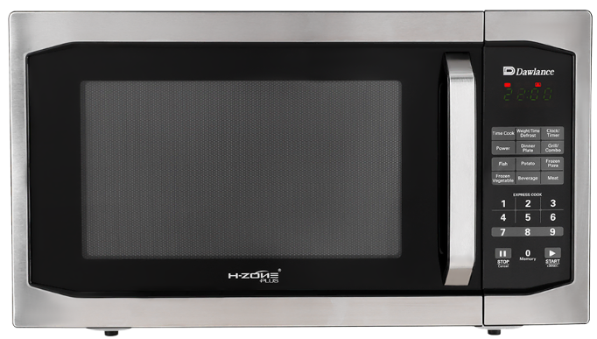
Rs.47,731
Dawlance DW-142-HZP grilling microwave oven combines microwave and grill cooking with digital controls and compact countertop convenience.

Specifications
- Model: DW-142-HZP
- Capacity: 20 Liters
- Microwave Power: 800W
- Grill Power: 1000W

Key Features
- Cook King menus
- Grill function
- 5 power levels
- Digital timer display

